 | PES University, Bengaluru  (Established under Karnataka Act No. 16 of 2013) | UE18CS314
OCTOBER 2020: IN SEMESTER ASSESSMENT B Tech 5 SEMESTER
TEST  2
UE18CS314 (4 credit)  APPLIED CRYPTOGRAPHY

Time: 2 Hrs | Answer All Questions | Max Marks: 40

1. | a) | Define the working of SHA -1 160.  Digest sizes: 160 bits  Block sizes: 512 bits  Certification: FIPS PUB 180-4, CRYPTREC (Monitored)  Rounds: 80  Structure: MerkleDamgård construction  First published: 1993 (SHA-0), 1995 (SHA-1)  Steps involved  - Padding of Bits  - Append Length  - Divide the input into 512-bit blocks  - Initialize chaining variables  - Process Blocks | 5
1. | b) | Differentiate between SHA and MD5. | 5
  1. | MD5 stands for Message Digest. | While SHA1 stands for Secure Hash Algorithm.
  2. | MD5 can have 128 bits length of message digest. | Whereas SHA1 can have 160 bits length of message digest.
  3. | The speed of MD5 is fast in comparison of SHA1s speed. | While the speed of SHA1 is slow in comparison of MD5s speed.
  4. | To make out the initial message the aggressor would want 2^128 operations whereas exploitation the MD5 algorithmic program. | On the opposite hand, in SHA1 itll be 2^160 that makes it quite troublesome to seek out.
  5. | MD5 is simple than SHA1. | While SHA1 is more complex than MD5.
  6. | MD5 provides indigent or poor security. | While it provides balanced or tolerable security.
  7. | In MD5, if the assailant needs to seek out the 2 messages having identical message digest then assailant would need to perform 2^64 operations. | Whereas in SHA1, assailant would need to perform 2^80 operations which is greater than MD5.
2. | a) | Explain the working of Kerberos KDC.  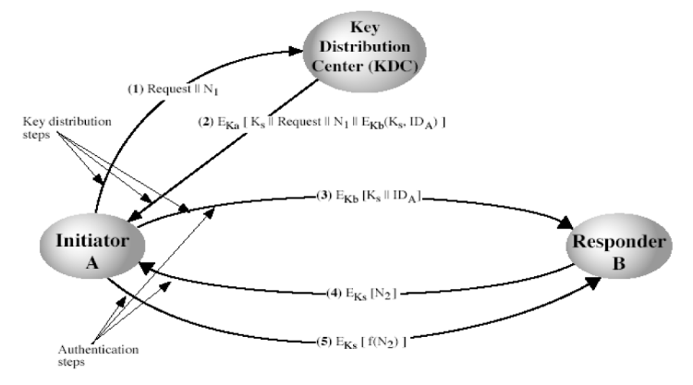  Key distribution step  Authentication steps | 5
2. | b) | Distinguish between challenge response and Zero knowledge entity authentication.  Challenge-response identification –  Strong authentication.  Cryptographic challenge-response protocols is that one entity (the claimant) proves its identity to another entity (the verifier) by demonstrating knowledge of a secret known to be associated with that entity, without revealing the secret itself to the verifier during the protocol.  This is done by providing a response to a time-variant challenge, where the response depends on both the entitys secret and the challenge.  The challenge is typically a number chosen by one entity (randomly and secretly) at the outset of the protocol.  If the communications line is monitored, the response from one execution of the identification protocol should not provide an adversary with useful information for a subsequent identification, as subsequent challenges will differ.  Challenge-response protocols can be realized by symmetric-key or asymmetric-key cryptography  Zero-Knowledge Proof –  ZKP concept.  A disadvantage of simple password protocols is that when a claimant A (called a prover in the context of zero-knowledge protocols) gives the verifier B her password, B can thereafter impersonate A.  Challenge-response protocols improve on this: A responds to Bs challenge to demonstrate knowledge of As secret in a time-variant manner, providing information not directly reusable by B.  Examples of ZKP.  Fiat-Shamir identification protocol.  Feige-Fiat-Shamir identification protocol.  Guilou-Quisquate identification protocol. | 5
3. | a) | Write two algorithms for RSA scheme:1. signing process and 2. verification process  RSA key generation phase  1. Select two prime numbers P and Q  2. Compute n=P*Q  3. Compute φ Euler's totient function.  Φ(n) = (p-1)(q-1)  4. Select e such that gcd(e, φ (n))=1  5. Determine ‘d’ as d*e = 1 mod φ (n)  Signing phase  - Alice creates a signature out of the message using her private exponent S =  - Sends Signature S and Message M to bob | 5
3. | b) | What makes digital signature different from conventional signatures?  - Inclusion: A conventional signature is included in the document; it is part of the document. But when we sign a document digitally, we send the signature as a separate document.  - Verification Method: For a conventional signature, when the recipient receives a document, she compares the signature on the document with the signature on file. For a digital signature, the recipient receives the message and the signature. The recipient needs to apply a verification technique to the combination of the message and the signature to verify the authenticity.  - Relationship: For a conventional signature, there is normally a one-to-many relationship between a signature and documents. For a digital signature, there is a one-to-one relationship between a signature and a message.  - Duplicity: In conventional signature, a copy of the signed document can be distinguished from the original one on file. In digital signature, there is no such distinction unless there is a factor of time on the document.  - reply attack possible on digital signature | 5
4. | a) | How is point multiplication achieved with elliptic curve?  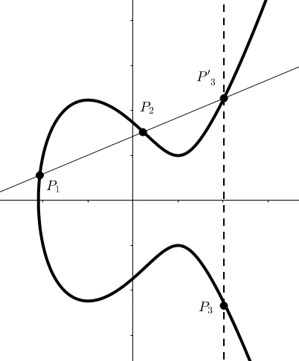  By considering P= QG  G base or generator point  Q scalar value  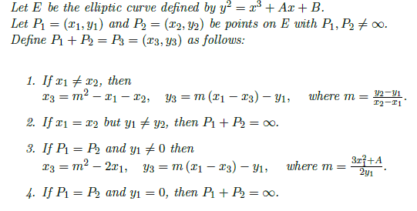 | 5
4. | b) | Consider the CBC-mode of encryption and authentication with a block cipher having a 256-bit key and 128-bit block length to encrypt a 1024-bit message. Find length of the resulting ciphertext?  1024+128=1152 | 2
4. | c) | Explain Point at infinity with respect to elliptic curve.  Defnition  if P1 = P2  y-coordinate equal zero, then the tangent line would not intersect any other point on E (K), other than the point itself.  For that reason, the point at infinity(1) is added as the identity element. This point can be viewed as being the top and bottom of the y-axis.  Cureve | 3

